Soil Hygrometer instructions
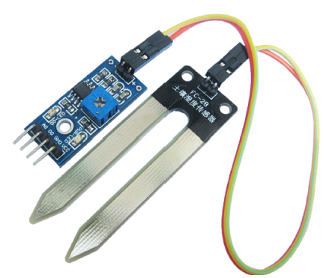

Product introduction:

1. Using the company's production of high-quality soil sensor for detection of soil moisture, and the surface of the nickel plating, widening of the sensing area can improve conductive properties, prevent soil contact is easy to rust, prolong service life;

2. The product can be a wide range of control soil humidity and control the corresponding threshold value by adjusting the potentiometer and the humidity is lower than set value, dissolved oxygen (do) to output the high level, higher than the set value, dissolved oxygen (do) output low level;

3 comparator using LM393 chip, stable operation

4 working voltage 3.3V-5V

5 a fixed bolt hole, easy to install

6.PCB size: 3.2cm * 1.4m

Wiring description (4 wire system):

1 VCC external 3.3V-5V

2 GND external GND

3 small DO digital output interface (0 and 1)

4 small AO analog output voltage

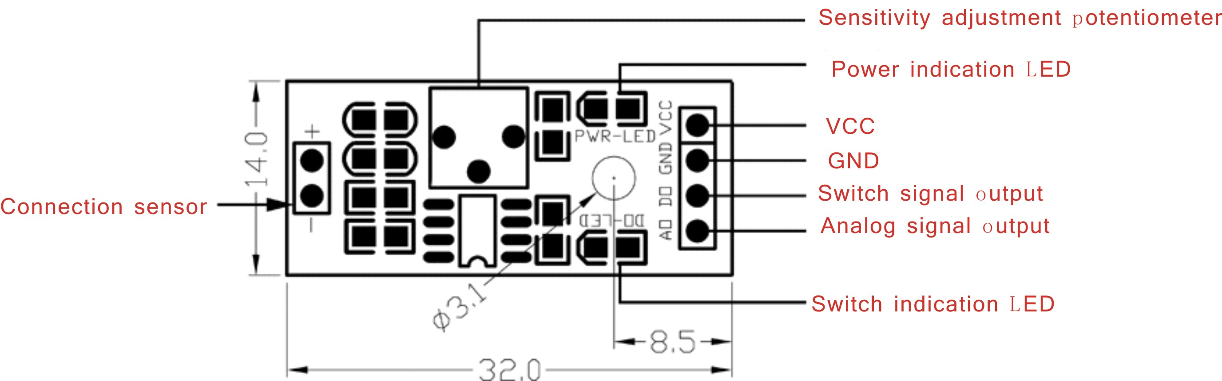

Module instruction:

1 sensors applied to the detection of soil moisture;

Module 2. Blue potentiometer is used to soil moisture threshold adjustment, clockwise adjustment and control the humidity will be bigger, counterclockwise smaller;

3 digital output D0 can be directly connected with the MCU, through the microcontroller to detect the level of high and low, which to detect soil moisture;

4 small analog output AO can be connected with the AD module through the AD conversion, can obtain more accurate values of soil moisture;

